**Hands on Assignment 2**

**MM19B027 Bhuvanesh P**

(i) The equilibrium bond length of CO as calculated from the program is 1.143679155 Ao units

(ii) By stretching the bond length by 0.001 Ao units we get energy plot as

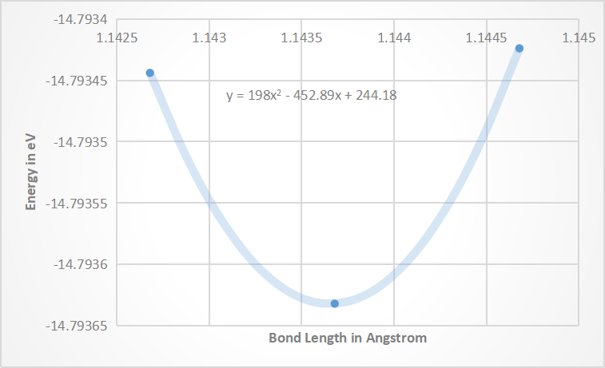

The equation that can be fitted is given by **y = 198x2 - 452.89x + 244.18**

In order to find the frequency

$$ω=\sqrt{\frac{α(w1+w2)}{w1 w2}}$$

The equation above gives the vibrational frequency between atoms.

We get $α$ after double differentiating the energy equation with respect t o distance

$α=\frac{d^{2}E}{dx^{2}}$ = 2 x 198 = 369

This is not in SI units to convert it we need to multiply by 1.6 X 10-19 in numerator and 10-20 in the denominator

$α=\frac{396X1.6X {10}^{-19}}{{10}^{-20}}=6336$

$$w1=\frac{12}{6.023X{10}^{-23}}$$

$$w2=\frac{16}{6.023X{10}^{-23}}$$

After substituting $ω$ is given by

$$ω=\sqrt{\frac{6336(\frac{12}{6.023X{10}^{23}}+ \frac{16}{6.023X{10}^{23}})}{ \frac{16}{6.023X{10}^{23}} \frac{12}{6.023X{10}^{23}}}}$$

$= \sqrt{\frac{63360 X \left(28\right) X 6.023}{192}} X {10}^{12}$

$$=235.907 X {10}^{12} Hz$$

(iii) By stretching the bond length by 0.02 Ao units we get energy plot as

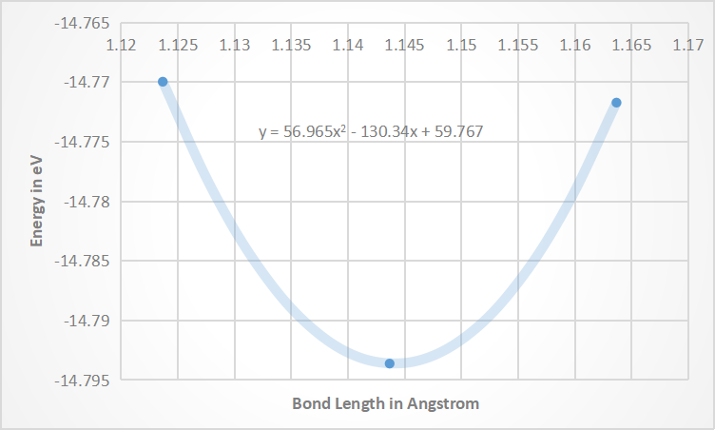

The equation that can be fitted is given by **y = 56.965x2 - 130.34x + 59.767**

In order to find the frequency

$$ω=\sqrt{\frac{α(w1+w2)}{w1 w2}}$$

The equation above gives the vibrational frequency between atoms.

We get $α$ after double differentiating the energy equation with respect t o distance

$α=\frac{d^{2}E}{dx^{2}}$ = 2 x 56.965 = 113.93

This is not in SI units to convert it we need to multiply by 1.6 X 10-19 in numerator and 10-20 in the denominator

$α=\frac{113.93X1.6X {10}^{-19}}{{10}^{-20}}=1822.88$

$$w1=\frac{12}{6.023X{10}^{-23}}$$

$$w2=\frac{16}{6.023X{10}^{-23}}$$

After substituting $ω$ is given by

$$ω=\sqrt{\frac{1822.88(\frac{12}{6.023X{10}^{23}}+ \frac{16}{6.023X{10}^{23}})}{ \frac{16}{6.023X{10}^{23}} \frac{12}{6.023X{10}^{23}}}}$$

$= \sqrt{\frac{18228.8 X \left(28\right) X 6.023}{192}} X {10}^{12}$

$$=126.539 X {10}^{12} Hz$$

(iv) By stretching the bond length by 0.2 Ao units we get energy plot as

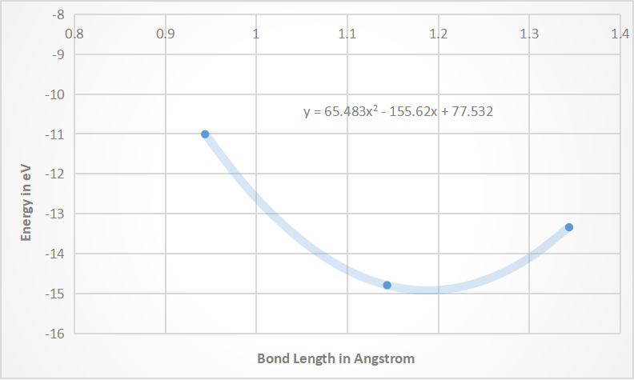

The equation that can be fitted is given by **y = 65.483x2 - 155.62x + 77.532**

In order to find the frequency

$$ω=\sqrt{\frac{α(w1+w2)}{w1 w2}}$$

The equation above gives the vibrational frequency between atoms.

We get $α$ after double differentiating the energy equation with respect t o distance

$α=\frac{d^{2}E}{dx^{2}}$ = 2 x 65.483= 130.966

This is not in SI units to convert it we need to multiply by 1.6 X 10-19 in numerator and 10-20 in the denominator

After substituting is given by